Crossover

Justin B. Lopez, Anthony Duque, Christian Padilla

**Creative Brief**

* **Purpose of app**- The app allows New Yorkers to check the availability of basketball courts in their area. It displays people that are checked in, gives an average of people per hour and allows users to check in when near a location
* **Goal**- The goal is to have people be able to stay informed about the number of people in the basketball courts around the location that they are in. we also want as many people to use the check-in service to gather as much data as possible in regards to how many people are in the courts.
* **Target Audience**- Our main audience are those primarily athletic and those who are interested in playing basketball in general. This audience will consist of young men and women of all ethnicities. This app will benefit urban residents the most.
* **Content**- the content of the app will include a the users current location wherever they are, a map that shows nearby basketball courts, list of the location of parks from closest to farthest, images of the parks that the courts are located, and a list of users who are at certain locations.
* **Functionalities**- The user will be able to register manually or have the option to sign up using other social media apps, you will be able to search for other users and locations of courts, and you will also be able to sign up for basketball tournaments.
* **Supported platforms**- IPhones and all Android devices.
* **Style**- The app style will be clean and clear so that it can be easy to use.

|  |  |
| --- | --- |
| **Kevin – 22 College Student from New York, NY** | |
| 1  *“Always stay two steps ahead on the court and in life.”* | **Personal Background**  Kevin has been playing basketball since he was 7 years old. He loves the sport and makes sure to practice every chance he gets at any public basketball court he can find. As much as he loves the sport he always makes sure to balance it with his schoolwork.  He finds trouble looking for a basketball court that isn’t full and would enjoy a way to know where are good places to practice and better his skills. With a dream of going pro in the NBA he strongly believes that practice his key.  Besides having interests in his work in college and basketball he also likes to make music, giving back to his community by participating in a charity based basketball game and helping out his family anyway he can. |

**Personas**

|  |  |
| --- | --- |
| **More About (add name)** | **Engagement & Activities** |
| **Motivators**  Kevin needs a way to be able to know what sort of public basketball courts are available and not already filled with people playing. His time is important to him and he can’t afford to be wasting time going to court to court.  **Goals**  Kevin heard of the crossover app and he is hoping to have an easier time searching for courts in order to have his practice time.  **Needs**  Kevin needs the app to be easy to use and reliable. | | **Personal Computer:** High / Fluent; comfortable with common apps  **Internet Usage:** High/ Fluent; Enjoys being on YouTube, Twitch, and ESPN.  **Mobile:** High/Fluent; frequently  **Social Networking:** (social comfort level, service used and for what purpose)  **Television Shows:**  **Magazines:** |

|  |
| --- |
| **Scenario** |
| (A narrative describing how the persona is using the website on one specific occasion. Including, but not limited to, the motivation to access the site, the environment in which the persona is when accessing the site, the device used to access the site, the way information is searched and accessed on the site, the response of the persona to the experience.) |

|  |  |
| --- | --- |
| **Joe – 20 College Student from New York, NY** | |
| *“You miss 100% of the shots you don’t take” – Michael Jordan* | **Personal Background**  Joe has been a fan of the NBA since watching Kobe Bryant play for the Lakers. He is a student at Hunter College in New York City who occupies his free time playing basketball at school during the winter and outdoors during the summer.  His hobbies don’t only include basketball, but he enjoys spending his time working and exploring New York City to see the different types of parks that are nearby. Living with only his mother a lot of his time and money go’s towards helping out however he can.  The use of this app would benefit his life in appositive way because always being equipped with his basketball shoes and ball, he’s always on the move and ready to take on a court for his daily workouts. With the app it will allow him to search for those nearby courts and conclude weather he’s equipped to play there or not. |

|  |  |
| --- | --- |
| **More About (add name)** | **Engagement & Activities** |
| **Motivators**  (The reasons persona want to use the website)  **Goals**  (What the persona is hoping to accomplish by using the website)  **Needs**  (What the persona needs from the website) | **Personal Computer:** (technical comfort level, app used)  **Internet Usage:** (comfort level, websites used, activities)  **Mobile:** (mobile comfort level, features used, app used)  **Social Networking:** (social comfort level, service used and for what purpose)  **Television Shows:**  **Magazines:** |

|  |
| --- |
| **Scenario** |
| (A narrative describing how the persona is using the website on one specific occasion. Including, but not limited to, the motivation to access the site, the environment in which the persona is when accessing the site, the device used to access the site, the way information is searched and accessed on the site, the response of the persona to the experience.) |

**Sketches**

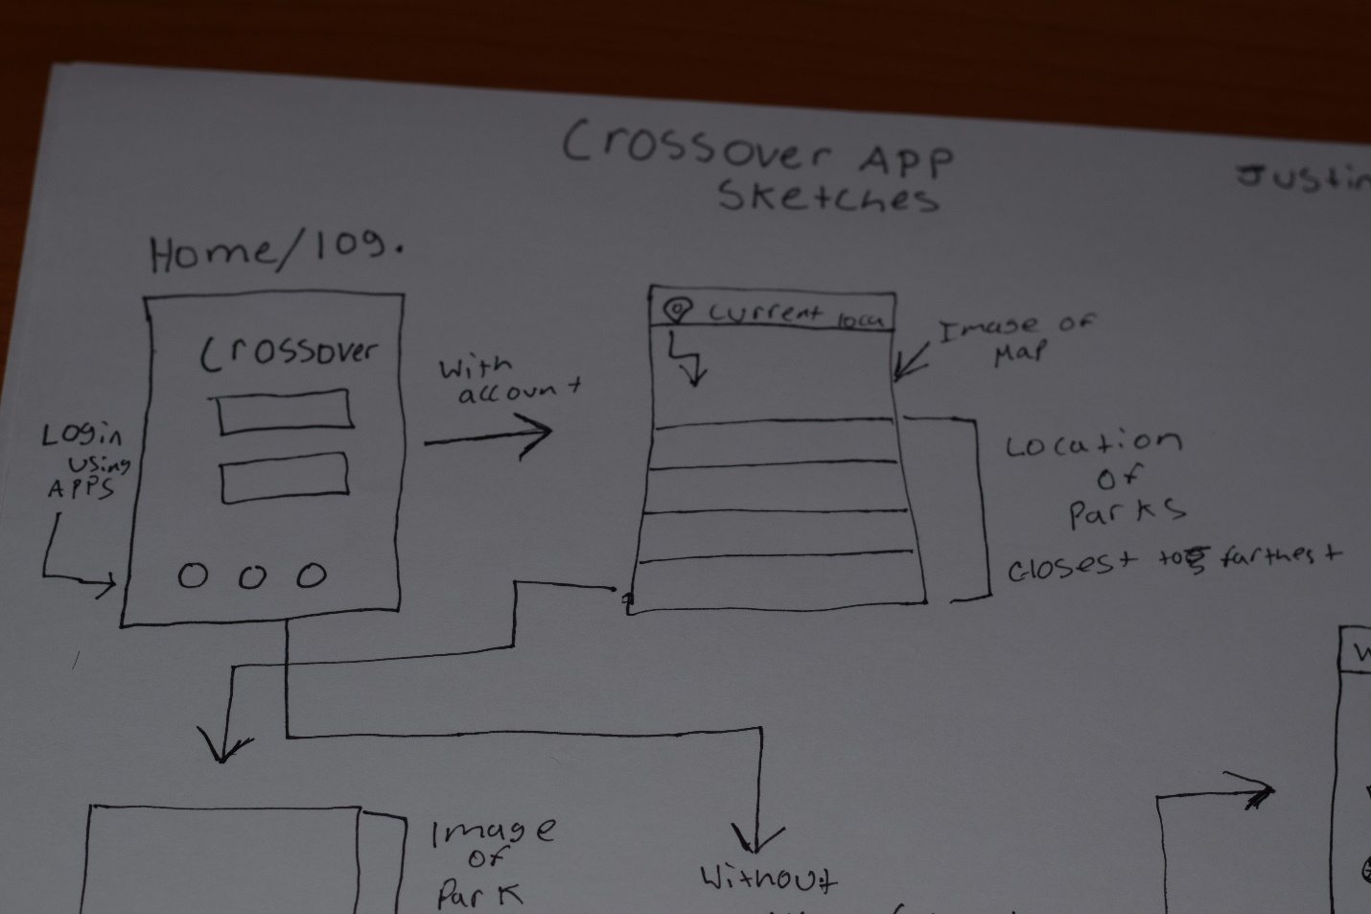

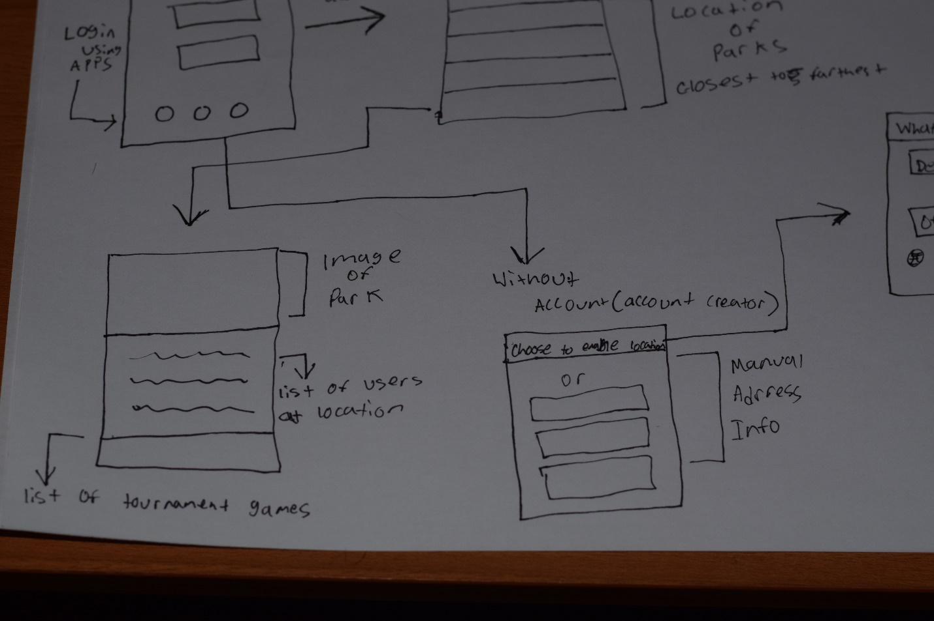

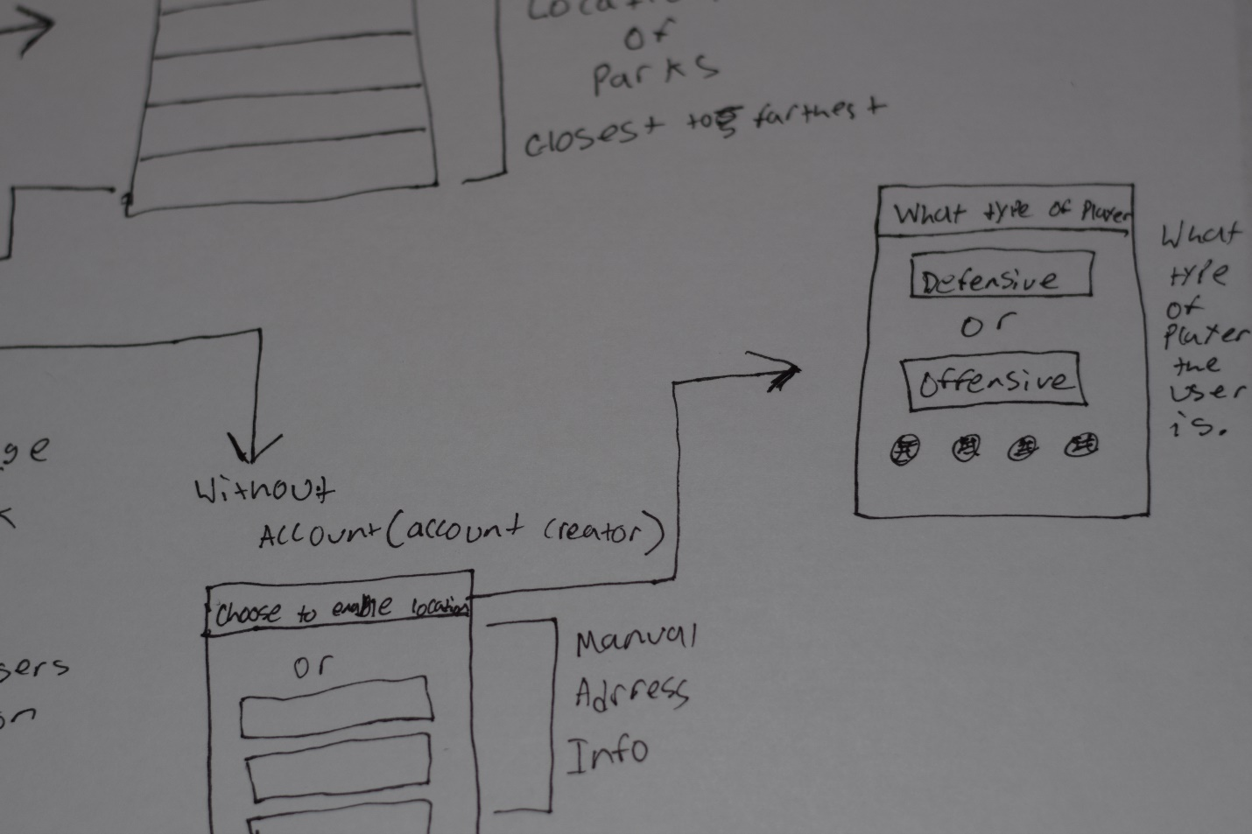

**Prototype**

<https://invis.io/ZVJ9M7RBAR2#/298719479_Crossover_Home>

The task that I prototyped was the main functions of the app itself. The prototype shows the screens that should appear when you first login, the main page that you will be welcomed to after the login is completed, and the screen that appears when the user taps on the list of parks that is shown on the main page.

**Testing Results**

What I mostly tested during this prototype was the functions of the screens being able to transition properly. I learned that making an app that functions well and figuring out a good design for it is not as easy as people would have you believe. It takes a good amount of steps of planning and cooperation with the members that are involve in designing the app. One of the only things that I would do to change the design of the app is to make it look cleaner. It seems to be clear enough to where the user is not confused but the design needs to have to have a more sharp/edgy look to it so it can feel smoother.